Ankara University | Department of Computer Engineering
BLM-275 | 06.01.2011
Digital Logic Design | Final Examination
Q1.
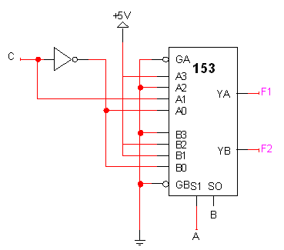
74LS153 is a dual 4x1 multiplexer that consists of two 4x1 multiplexer in it. It has two selection lines S1 and S0. For example, when S1S0=00, outputs YA=A0 and YB=B0. The figure at right shows an implementation for two functions F1 and F2. The inputs to the circuit are ABC.
a. Find the functions F1 and F2 using K-maps. [10]
b. Implement the function using 3 input 2 output PLA with four AND gates. Show only the programming table.[10]

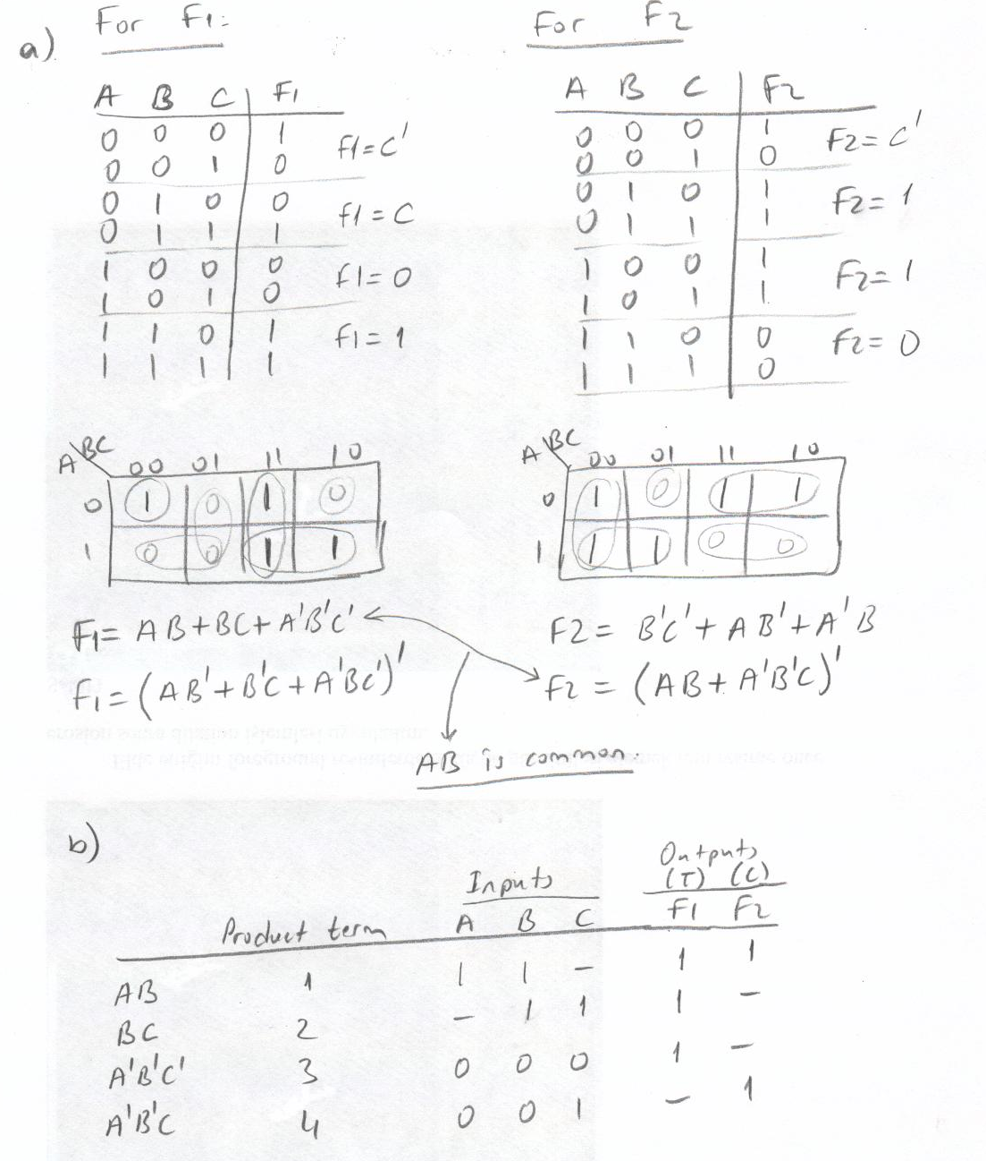

Q2.
A ROM circuit with 3 inputs having 2 bits in each cell is used to implement two functions F and G. The implementation is given below. Determine the functions F and G in their minimized forms. | 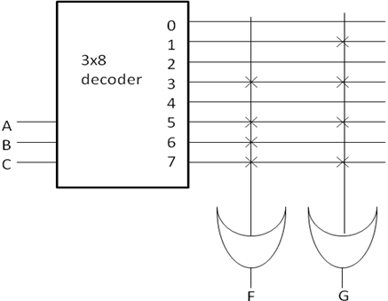
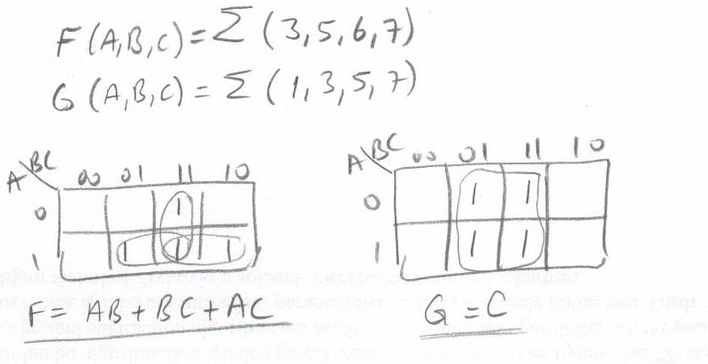
Q3. We use Hamming codes to correct single bit error in a string of bits. When we have 4 bits (), we use 3 parity bits (, , and ) in the order of . Each parity bit is used for a combination of bits in the data. However, if there is more than one error in the string, we cannot find erroneous bits. If we add extra parity bit () to the string, we can detect two bit errors and correct one bit errors. When we add to the Hamming code, it becomes as .
Find if there is an error in the following bit strings. If there is, how many bits are incorrect? Locate the incorrect bit if there is only one erroneous bit.
a. b.
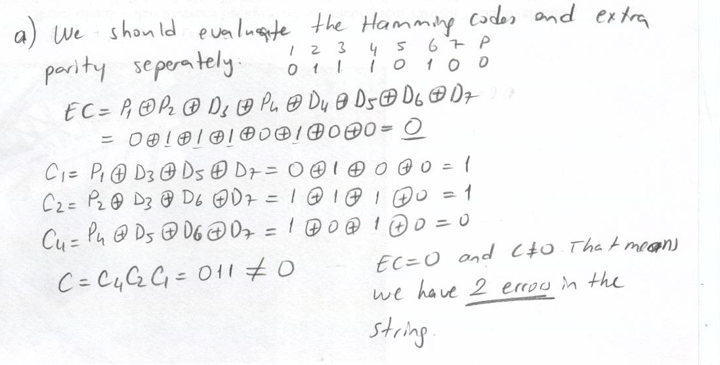
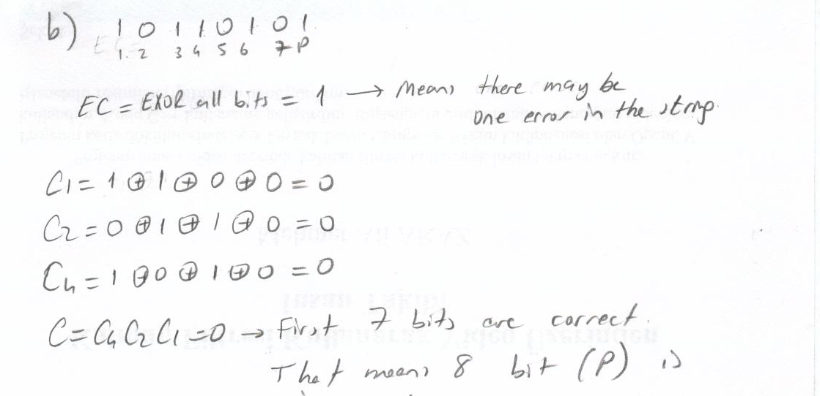

Q4. For the sequential circuit given at right, write  a. Input equations and state table.[10]  b. State equations and output equation.[6]  c. State diagram. [4] | 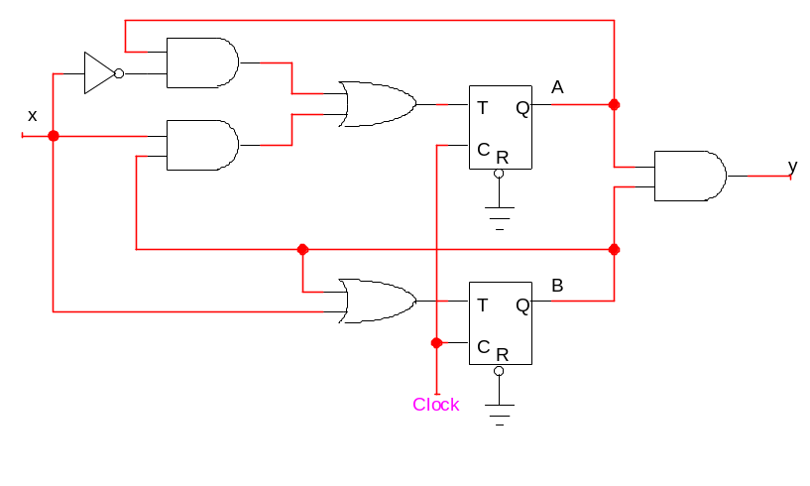
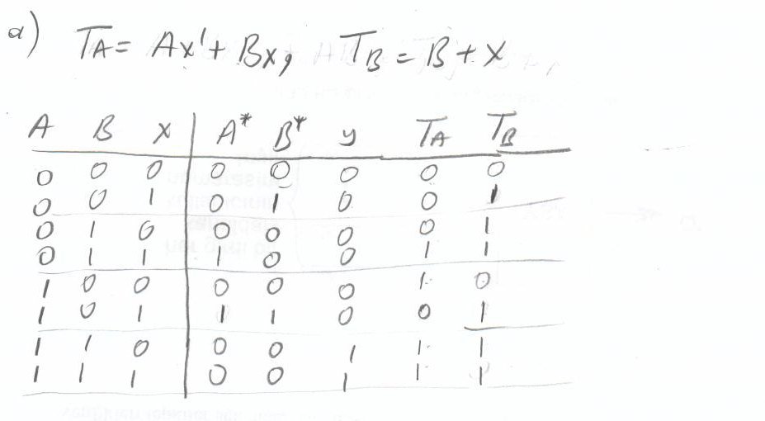
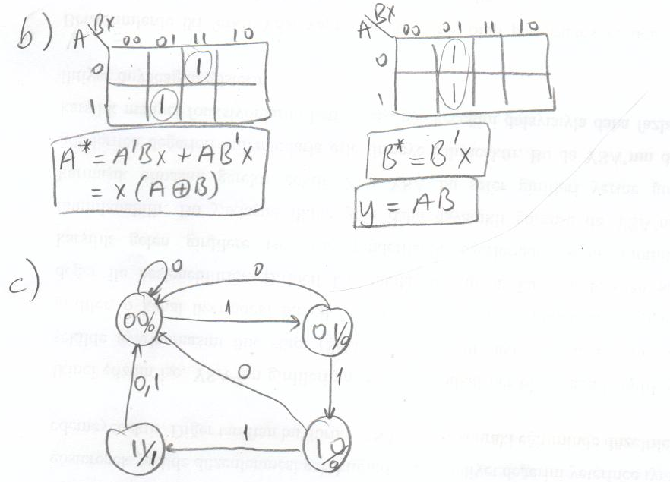

Q5. Design a Mealy type state machine with input X and output Y. Y should be 1 whenever the sequence 110 or 101 has been detected on X on the last 3 consecutive rising clock edges (or ticks). Otherwise, Y=0. Use at most two D flip-flops. An example input–output combination is given below:

X | 0 | 0 | 1 | 1 | 0 | 0 | 1 | 0 | 1 | 0 | 0 | 1 | 1 | 1 | 0 | 1 | 0 | 0 | 1 | 0 | 1 | 1 | 0 | 0 | 1 | 1 | 0 | 0 | 1 | 1
Y | 0 | 0 | 0 | 0 | 1 | 0 | 0 | 0 | 1 | 0 | 0 | 0 | 0 | 0 | 1 | 1 | 0 | 0 | 0 | 0 | 1 | 0 | 1 | 0 | 0 | 0 | 1 | 0 | 0 | 0

You should show:
a. State diagram. [16]
b. State table. [6]
c. Flip flop input equations and output equation. [8]
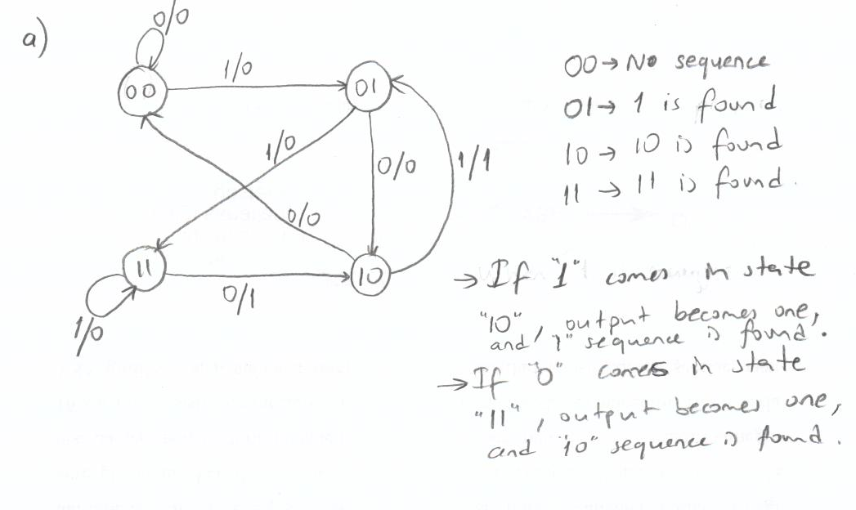
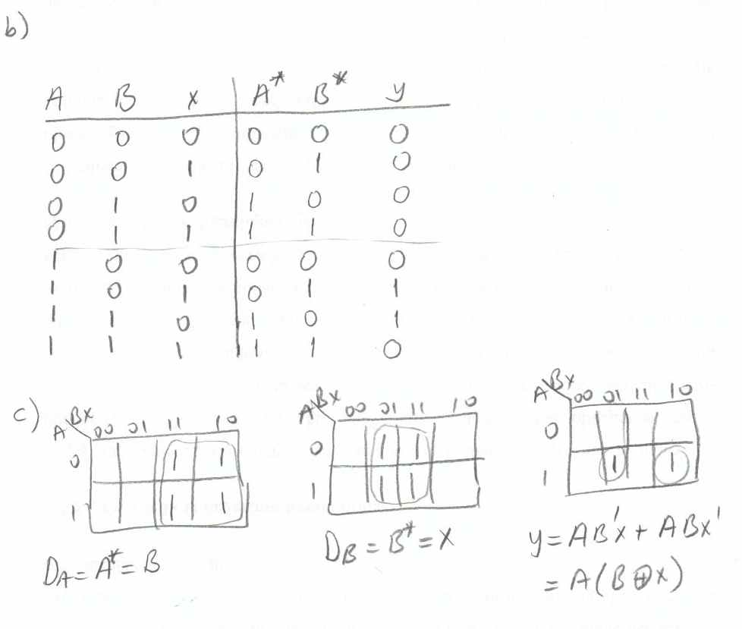
Q6.The state diagram of a sequential circuit is given below. In this circuit, two JK flip flops are used. The flip flop input and output equations are as follows:
Based on the above specifications, what are the next states of unused state? The unused state is .
